# Color histogram report

## Design:

**Input**: one image file with RGB colors

**Process**:

1. Take an image file and the quantization of Blue, Green and Red as four input parameters.
2. Store the image into a matric.
3. Decide the number of bins based on the quantization of three colors (bin = rq*gq*bq).
4. Initialize the color histogram vector to zeros.
5. Based on the quantization of tree colors, decide the boundary of each bin.
6. Based on the RGB value of one pixel, plus 1 to the correct bin.
7. Return color histogram vector.

**Output**: a color histogram vector

## Test result:

1. Test with 1.jpg. The quantization of blue, green and red are 4, 4, and 4. The output is a vector of color histogram.

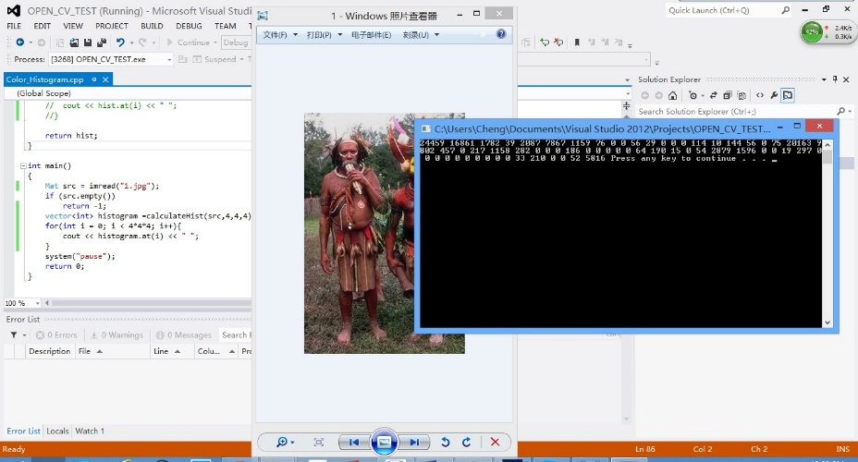

1. Test with 8.jpg. The quantization of blue, green and red are 5, 7, and 3. The output is a vector of color histogram.

